**Eligibility for Mobilization**

**Objective:**

The primary objective of this analysis is to determine the optimal windows for mobilizing patients on invasive ventilation, focusing specifically on the first 72 hours following intubation and within standard business hours (8:00 AM to 5:00 PM). The mobilization criteria are based on three distinct frameworks: the **Patel et al. Criteria**, the **TEAM Criteria**, and the **Consensus Criteria**.

**Cohort Definition:**

This analysis encompasses **5,249 unique encounters** at UC from **March 1, 2020, to March 31, 2022**. The cohort consists of patients who were placed on invasive ventilation at any point during their hospitalization. Encounters were excluded from the analysis based on the following criteria:

* Ventilation duration of less than 2 hours.
* Patients who underwent tracheostomy within 72 hours of their first intubation.

**Mobilization Criteria:**

The mobilization windows are determined based on the following criteria sets:

**1. Patel et al. Criteria:**

These criteria are based on maintaining hemodynamic and respiratory stability, defined by the following parameters:

* **Mean arterial blood pressure (MAP):** 65–110 mm Hg
* **Systolic blood pressure:** ≤ 200 mm Hg
* **Heart rate:** 40–130 beats per minute
* **Respiratory rate:** 5–40 breaths per minute
* **Pulse oximetry (SpO2):** ≥ 88%

**2. TEAM Criteria:**

These criteria are designed to ensure stability across cardiovascular and respiratory systems, considering noradrenaline infusion and lactate levels:

* **Heart rate:** ≤ 150 beats per minute
* **Most recent lactate level:** ≤ 4.0 mmol/L
* **Noradrenaline infusion rate:** 0.1–0.2 mcg/kg/min (calculated Norepinephrine equivalents were used in this analysis)
* **Respiratory stability:**
  + **FiO2:** ≤ 0.6
  + **PEEP:** ≤ 16 cm H2O (based on observed PEEP values)
* **Current respiratory rate:** ≤ 45 breaths per minute (based on observed respiratory rate)

**3. Consensus Criteria:**

The consensus criteria are divided into **Green**, **Yellow**, and **Red** categories based on respiratory and cardiovascular parameters.

**Green Criteria:**

* **Respiratory:**
  + SpO2 ≥ 90%
  + Respiratory rate ≤ 30 breaths per minute
  + FiO2 ≤ 0.6
  + PEEP ≤ 10 cm H2O
* **Cardiovascular:**
  + MAP ≥ 65 mm Hg with no or low-level support (Norepinephrine infusion rate < 0.1 mcg/kg/min)
  + Heart rate < 120 beats per minute
  + Lactate < 4 mmol/L
  + Heart rate > 40 beats per minute

**Yellow Criteria:**

* **Respiratory:**
  + SpO2 ≥ 90%
  + FiO2 > 0.6
  + Respiratory rate > 30 breaths per minute
  + PEEP > 10 cm H2O
* **Cardiovascular:**
  + MAP ≥ 65 mm Hg with moderate support (Norepinephrine infusion rate 0.1–0.3 mcg/kg/min)
  + Heart rate 120–150 beats per minute
  + Shock with lactate > 4 mmol/L
  + Heart rate > 40 beats per minute

**Red Criteria:**

* **Respiratory:**
  + SpO2 < 90%
* **Cardiovascular:**
  + MAP < 65 mm Hg despite support or MAP ≥ 65 mm Hg but on high-level support (Norepinephrine infusion rate > 0.3 mcg/kg/min)
  + IV therapy for hypertensive emergencies (SBP > 200 mm Hg or MAP > 110 mm Hg, with administration of nicardipine, nitroprusside, or clevidipine)
  + Heart rate > 150 beats per minute
  + Bradycardia (heart rate < 40 beats per minute)

**Results**

**Figure 1: Total number of encounters satisfied by each criteria**

**Figure 2: Number of hours for criteria satisfaction**

Note:

1. Green criteria: All green subcomponents and none of the red subcomponents are satisfied
2. Yellow criteria: Any yellow or green subcomponents are satisfied, but no red
3. Red criteria: Any red subcomponents are satisfied

Subcomponent failures

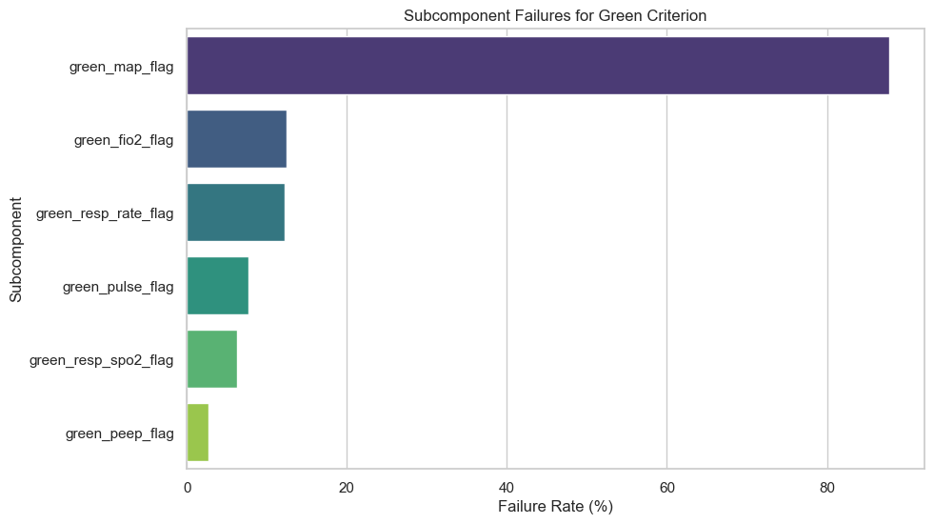

These three graphs look at 100 random encounters from the cohort. X axis denotes the time of first intubation (time = 0). This analysis checks for eligibility for mobilization during the 27 business hours after the first intubation. Each row on the Y axis represents an encounter. The green cell shows the patient was eligible to be mobilized during that hour, and the red is opposite.

